**UNIVERSITY OF GHANA**

**DEPARTMENT OF COMPUTER SCIENCE**

**MOBILE DEVELOPMENT SHORT COURSE EXAMINATION**

***Instructions****: Answer* ***all*** *questions in* ***Section A****, any other* ***two*** *questions from* ***Section B*** *and* ***one*** *practical test in* ***Section C***

**DURATION: 3** hours and **30** minutes only

**SECTION A (20 marks)**

**DURATION: 45mins**

1. What is the main difference between set and list in android?
2. Both are the same
3. Set can’t contain duplicate values
4. List may contain duplicate values
5. B & C
6. What are commands needed to create APK in android?
7. No need to write any commands
8. Create apk_android in command line
9. Javac, dxtool, aapt tool, jarsigner tool and zipalign
10. None of the above
11. Fragment in Android can be found through
12. findByID()
13. findFragmentByID()
14. getContext.findFragmentByID()
15. FragmentManager.findFragmentByID()
16. Object-oriented programming is a ……….. language model organized around ………. rather than ……….. and ……. rather than ……
17. Programming, data, actions, objects, logic
18. Programming, data, logic, actions, objects
19. Objects, data, actions, logic, programming
20. Programming, objects, actions, data, logic
21. The primary purpose of object-oriented programming is……
22. To increase reusability of codes.
23. To increase flexibility and maintainability of programs.
24. To reduce the length and complexity of the programs.
25. All of the above
26. An object is a……
27. Bundle of other objects
28. Collection of items of the same type
29. Bundle of data and its behavior
30. None of the above
31. What is the library of Map View in android?
32. com.map
33. com.gogglemaps
34. in.maps
35. com.google.android.maps
36. Persist data can be stored in android through
37. Shared preferences
38. Internal/ external storage
39. SQLite
40. All the above
41. What is the difference between services and thread in android?
42. Services performs functionalities in the background. By default, services run on main thread only
43. Thread and services are having same functionalities
44. Thread works on services
45. None of the above
46. What are the layouts available in android?
47. LinearLayout
48. FrameLayout
49. RelativeLayout
50. All of the above
51. How to kill an activity in android?
52. finish()
53. finishActivity(int requestCode)
54. A & B
55. kill()
56. How can we bring up a pop up a menu?
57. inflate()
58. popup()
59. A & B
60. None of the above
61. How is a service class created?
62. Inherit from the service class
63. Use <service> tag
64. A & B
65. None of the above
66. Why are intent filters written?
67. To find a suitable component
68. In dynamic broadcast receiver
69. A & B
70. None of the above
71. Why is Log.d() used?
72. Dalvik Log
73. Debug log
74. Daemon log
75. DDMS log

**SECTION B (40 marks each)**

**DURATION: 1hr15mins**

Q1. A). Briefly describe the following:

1. Java as an object-oriented programming language.
2. Object Oriented programming

B). i. What is an object?

Ii. State 3 properties of an object with respect to the concept of abstraction.

C). Explain the following concepts:

i. Abstraction

ii. Encapsulation

iii. Inheritance

iv. Aggregation

v. Composition

Q2. A). i. What is mobile development?

ii. What is android?

B). i. What is constructor?

ii. State and explain the various types of constructors available

C). i. Explain the term “method overloading”?

ii. Write down two simple overloaded methods to back your definition above.

D). i. Distinguish between a constructor and a method.

Consider the following:

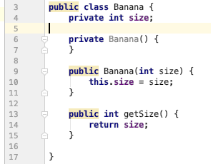

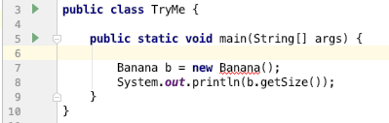

1. What do you think is wrong with the code snippet above? Explain and resolve the issue.
2. When you run the TryMe.main() method, what will be the result?
3. What will be the output of this code?

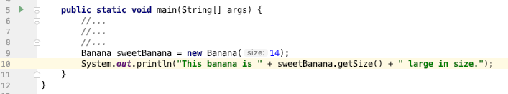

Q3. A). Define with an example two of any of the following:

1. Class
2. Variable
3. Method

B). Create an array of sting objects and assign string to each element. Print an array using a for loop.

[Hint: String [] arr= new String {…………………….};]

[Hint: for (int index=11; index <=25; index++) </*Some code*/>]

C).

DataModel model = new DataModel (5);

DataModel otherModel = new DataModel (4,’’Nice name here”);

DataModel somethingElse = new DataModel ();

1. Based on the constructors above, define the method overloading.
2. What type of constructor is used in:
3. Line a

Line b

**SECTION C (60 marks)**

**DURATION: 1hr30mins**

You are required to create a **ToDo** application in android studio that performs the following functions:

I. Add a ToDo item to a list of other ToDo items

ii. View all ToDo items in a list form

The application should be called: “**ToDo Application**”

The package name should be: **exam.todoapp**

The minimum API level should be: **21**

The application should have 2 classes predefined: TodoItem.java and AddNoteActivity.java

Download the existing project from the GitHub repository and launch it in android studio.

Click on the TODO tab in the bottom pane of the Android Studio IDE to view all the tasks you are supposed to do.

Make sure to clear the TODO comment in your code when you solve each one.

The final application should look like this:

